



Indexers Are The Genealogist’s Best Friend

HSGS’s Web Site. Our web site is no longer hosted by rootsweb.com, and has gone through a major change in the last several months, and still needs several charges that are noted below in italics. Our address now is www.usgenweb.org/mi, and then select Iosco County and three tables will appear: (1) Iosco County Resources, (2) State of Michigan Resources, and (3) United States National Resources:
- If you wish to do a SIMPLE SEARCH of all Iosco County indexes (including HSGS indexes): From the “Iosco County Resources Table” go to the search block, titled Search the USGenWeb Archives, in the lower left corner of the Iosco County Resources Table and enter you search words and click on the word “<<Iosco.”
- If your wish to do an ADVANCE SEARCH all of Iosco County indexes (Including HSGS indexes): From the “Iosco County Resources Table” click on the word “<<Iosco” in the search block in the lower left corner titled Search the USGenWeb Archives and an advanced search menu will appear; then fill in the options offered on the search menu (Be sure Iosco County is selected) and then click search. (At this time the index titles do not appear in the search results. We have asked that the title be made mandatory, or at least optional).
- If you wish only to BROWSE all the HSGS indexes: Go to the “State of Michigan Resources Table” and click on Huron Shores Genealogical Society Michigan Archives Collection. At this time there is no search engine just for the HSGS’s indexes. (We have asked that one be added to this page. Also we have asked that this page be moved to the Iosco County Resource Table and that Michigan be removed from the title).
- If you wish to READ our Newsletters from 2004-2008: Go to the “Iosco County Resources Table” and click on the block title. HSGS Newsletters.

We currently have 1,265 indexes, 30,433 printed pages, and 1,343,248 name citations indexed: If indexes were printed out they would be about 9 feet tall and weighs about 300 pounds.

All these files are on HSGS’s master file on our computers external hard drives, & on a 2-CD set that we sell. But only about 98% are on the web site (Which does not include about 10-20 new indexes within the last month or two, draft indexes not yet finished, & a some administrative corrections). The history and current status of our master indexes & CD follows:

Master Index Status | Aug | Sep | Oct | Nov | Dec | Jan | Feb | Mar | Apr | MAY | Jun | Jul
Current | 1057 | 1063 | 1081 | 1104 | 1122 | 1130 | 1138 | 1147 | 1169 | 1178 | 1191 | 1201
Outdated (Introduction) | 30 | 30 | 30 | 30 | 30 | 30 | 30 | 30 | 30 | 30 | 30 | 30
New This Month | 6 | 18 | 22 | 15 | 12 | 8 | 10 | 22 | 9 | 15 | 10 | 5
Editing In Progress | 7 | 7 | 7 | 7 | 7 | 7 | 7 | 7 | 7 | 6 | 6 | 6
Partially Done | 23 | 23 | 23 | 23 | 23 | 23 | 26 | 23 | 26 | 23 | 23 | 23
Totals | 1123 | 1141 | 1163 | 1179 | 1194 | 1198 | 1211 | 1229 | 1241 | 1252 | 1258 | 1265

HSGS member and Vice-president Dan Stock is HSGS’s Web Master and places our indexes directly on our USGENWEB web site.

Indexes Added This Month:
- The Herald: 1936(06), 1936(07), 1936(08), 1936(09). By Joan Doerr of Ellicott City MD.
- Alcona County Newspaper Clippings of Vital Records: 1877-1899. By Robert L Ferret of Ypsilanti MI & Donald A Ferrett of the State of Virginia.

New Books This Month, donated by Robert L Ferret & Donald A Ferrett:
- Birth, Marriages, Divorces, Bigamy, & Death Notices from the Alcona County Review & a few from the Alcona County Herald, Vol 2 1900-1909 (Final).

Files Scanned This Month, by Alonzo Sherman:
- Upson, Charles Mrs & Mrs

HSGS’s Treasurers Report: Cash $36.13, Savings $1,259.78, Checking $935.92 = Total $2,231.83.
TRAINING AVAILABLE (One Time Events):

Year/Mo/Day | Description/Location/Contact
2008/Summer | The Traveling Exhibition, America’s Heritage: A History of U. S. Immigration is coming this summer to the Castle Museum in Saginaw MI. More info call Irene Hensinger at 989-752-2862 Ext 301.
2009/10/15-19 | Midland Genealogical Society Seminar, Valley Plaza Resort in Midland MI. More info later.


HURON SHORES GENEALOGICALSOCIETY ACTIVE MEMBERS.

C/o Robert J Parks Public Library, 6010 N Skeel Ave, Oscoda MI 48750, and Phone 989-739-9581. The Library is open Mon, Fri & Sat 9:00am-5:00pm & Tue-Wed-Thur 9am-8:00pm (HSGS member available by chance or appointment). Officers, active project leaders and indexers are listed below:

Name | Current Projects | Phone & E-mail
Anschuetz, Greta L | Transcribing the Warblers | 215-694-9332, <gretala80@yahoo.com>
Birnbaum, Charles | Iosco County Death Indexes, News Herald Index, Saginaw News Obits | 989-362-5994 <Birnbaumcr@hotmail.com>
Carraway, Marianne | WAFB Newspaper 1955-1993 | 989-739-9569 <mcarraway@charter.mi.net>
Daniels, Lugene | On ballot for 2008 Secretary, Burleigh Twp Farming | 989-756-3852
Doerr, Joan | Tawas Herald Newspaper Index | 410-461-1407 <JoanDoerr@hotmail.com>
Donaldson, James | Assists,with His Oscoda Press Collection | 313-835-2440 <ab6943@wayne.edu>
Farrand, Jim | Transcribing the Warblers | 989-469-2308 <farrand@charter.net>
Gervais, Eileen | Transcribing the Warblers | 989-469-3524  <jgervais@centrytel.net>
Johnson, Barbara | Transcribing the Warblers | 952-934-7797, <bjohnson@edenpr.org>
MacMurray, Jim | Tawas School Yearbooks | 330-824-34230  jimm14@aol.com
Petee, Bonnie | Transcribing various records | 810-636-9348 <gypsy2@chartermi.net>
Sheldon, Judy | Treasurer & Secretary | 989-739-5497 <judesheldon@yahoo.com>
Sherman, Alonzo | Librarian/Publications/Indexes. | 989-739-3650 <shermanaj@hotmail.com>
Stock, Dan | Vice-president & web master | 989-739-4239 <etts95@yahoo.com>
Stonehouse, Naomi | President, writing local booklets | 989-362-8187 <alvene2000@yahoo.com>
Summers. Leona | Oscoda Press Index | 989-724-6510 <none>

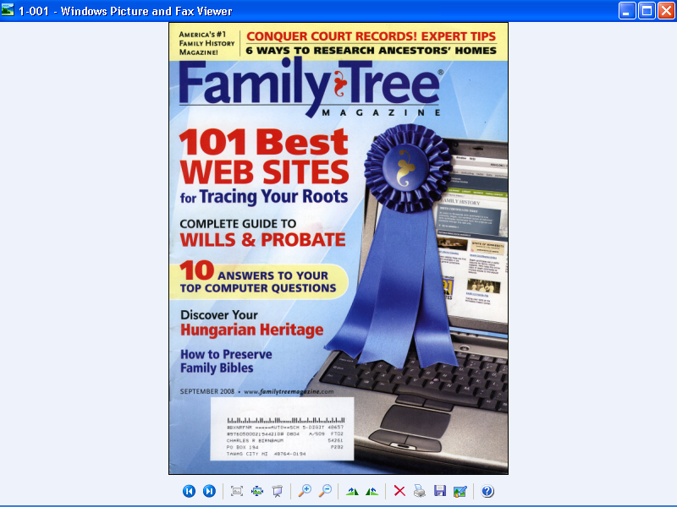

See the next page for an article in this magazine.
